**Nitte Meenakshi Institute of Technology**

(AN AUTONOMOUS INSTITUTION AFFILIATED TO VISVESVARAYA TECHNOLOGICAL UNIVERSITY, BELGAUR)

PB No. 6429, Yelahanka, Bangalore 560-064, Karnataka

Telephone: 080- 22167800, 22167860

Fax: 080 – 22167805



**SOFTWARE ENGINEERING LA1 COMPONENT’S REPORT**

On

**SOFTWARE REQUIREMENT DOCUMENTATION OF MakeMyTrip APPLICATION**

**“Functional and non-functional requirements”**

Submitted by:

Bibek Yadav 1NT19CS055

Branch: CSE

Sec: 5 ‘C’

Submitted to:

Dr. Vasantha Kumar G U

# **TABLE OF CONTENTS**

1. **ACKNOWLEDGEMENT ………………………………………3**
2. **INTRODUCTION…………………………………………………4**
3. **OVERVIEW……………………………………………………… 5**
4. **INTRODUCTION TO MakeMyTrip……………………… 6 – 8**
5. **FOUNDER OF MakeMyTrip**
6. **FEATURES OF MakeMyTrip**
7. **FUNCTIONAL REQUIREMENT……………………………8 -13**
8. **NON-FUNCTIONAL REQUIREMENT……………………13-14**

1. **UML DIAGRAM………………………………………………..14**
2. **CONCLUSION & IMPROVEMENTS………………………**

# **ACKNOWLEDGEMENT**

I would like to express my special thanks of gratitude to my teacher Dr. Vasantha Kumar G U as who gave us the golden opportunity to do this wonderful demonstration on the topic Functional and Non-functional requirement of any application, which also helped me in doing a lot of Research and I came to know about so many new things I am really thankful to them.

Secondly, I would also like to thank my friends who helped me a lot in finalizing this project within the limited time frame.

# **INTRODUCTION**

As this report gives the brief description of functional and nonfunctional requirement of MakeMyTrip, an online travel company application. This report will describe about the software requirement of MakeMyTrip application. This document is intended for the stakeholder of application, to assist the development process of MakeMyTrip as well as to serve a reference to clarify any future issues that the stakeholders may run into. The main purpose of this report is to demonstrate the full overview of functional and non-functional requirements of MakeMyTrip where only network access is needed for running this application.

# **OVERVIEW**

This report gives an overview of online travel company application known as MakeMyTrip where it includes the software requirements for the given application. You can see the topic on the table of contents above. On the first part you get the brief introduction of the report where you get knowledge on what topic is this report is done. On the second part you will see the introduction on MakeMyTrip .The third section is about the Functional and Non-Functional requirement of this application. The fourth section gives the UML diagram with the brief description about the flow on the given diagram below. On the final part it’s the conclusion with the improvement that can be done for this application.

# **INTRODUCTION ON Makemytrip**

In today’s era of globalization and advanced technology, the travel industry demands reliable and fast travel services.  As the choices of travel services have increased over the years, the internet has become the easiest, quickest, and most comfortable platform to compare prices and to place booking orders for tickets. All over the world including India, travellers prefer to avail of the online facility to book tickets and hotels through the internet. One of the pioneered names in the online travel business is MakeMyTrip in India.

FOUNDER OF MakeMyTrip:

MakeMyTrip was founded in the year 2000 by a Delhi based entrepreneur Deep Kalra who is an MBA from IIM Ahmedabad. He had started the professional journey of his career in ABN AMRO bank and worked for 3 years. He further experimented with his entrepreneurial skills by working with AMF Bowling for setting up bowling alleys in India. He couldn’t get much success in it and soon he left that and joined GE Capital as Vice president-Business Development in 1999. This was that time when he was exploring the internet and its great potential in impacting our day to day life.  When he was planning to book a Thailand holiday, he realized that different competitive price options were available on the internet but there wasn’t any intermediary involved in the process. This thought prompted him to try for entrepreneurship again with a different idea and finally, in April 2000, MakeMyTrip was introduced.

# **FEATURES OF Makemytrip:**

Features that MakeMyTrip Modules Have

* Fare Calendar
* Multiple Supplier Inventory
* Offline Flight Inventory Management
* Custom Home Page Design
* Blog management
* Website Management
* SEO Friendly
* Google Analytics
* MIS Reports for Administrator and Agents
* Page Management
* SSL Secure website
* E-Ticket (Email or SMS)
* Pre-Integrated GDS & APIs.
* Responsive design
* Social media login Integration
* Customer dashboard
* Convenience Fee Management
* Unlimited Bandwidth
* Customer Feedback

# **FUNTIONAL REQUIREMENT:**

A **Functional Requirement** (FR) is a description of the service that the software must offer. It describes a software system or its component. A function is nothing but inputs to the software system, its behavior, and outputs. It can be a calculation, data manipulation, business process, user interaction, or any other specific functionality which defines what function a system is likely to perform. Functional Requirements in Software Engineering are also called **Functional Specification**.

In software engineering and systems engineering, a Functional Requirement can range from the high-level abstract statement of the sender’s necessity to detailed mathematical functional requirement specifications. [Functional software](https://www.guru99.com/learn-software-requirements-analysis-with-case-study.html) requirements help you to capture the intended behavior of the system.

Functional requirement for MakeMyTrip application are as follows:

1. **User Registration**

The Customer Should be able to register with their details.

The system should record the following customer details into member database.

.Name

.Email

.Password

.Address

.DOB

The system shall send verification messages to email.

1. **Login**

After succesfull registration to the Application. Customer can login to app with basic details like mobile number and passwords

1. **Reservation**

After Login To application , Customer can search for their requirements like

1. Flights

2. Hotels

3. Train tickets

4. Holidays trips

5. Bus

6. Car/Taxi etc.

1. **Confirming Bookings**

Input

Select or click on train/bus/flight and number of persons travelling

Processing

Fetch the seat availability and if not available displays an error message.

Output

Redirects to payment gateway if seats are available

1. **Payment Gateways**

Input

Card details including card number, CVV, expiry date.•

Processing

Checks the information provided to bank server. If successful, money gets debitedfrom user bank account and credited to site owners account, else display error.

Output

Message registered successful if no error was generated else display error message

1. **Refer And Earn**

Customers can refer their links to others, like their family and friends to connect with MakeMyTrip and as many people gets connected with their refered link as much they earn and they can use that amount for their other bookings on makemytrip.

# **NON-FUNCTIONAL REQUIREMENTS**

**Non-Functional Requirement** (NFR) specifies the quality attribute of a software system. They judge the software system based on Responsiveness, Usability, Security, Portability, and other non-functional standards that are critical to the success of the software system. Example of nonfunctional requirement, “how fast does the website load?” Failing to meet non-functional requirements can result in systems that fail to satisfy user needs.

Non-Functional requirements in Software Engineering allows you to impose constraints or restrictions on the design of the system across the various agile backlogs. Example, the site should load in 3 seconds when the number of simultaneous users is > 10000. Description of non-functional requirements is just as critical as a functional requirement.

**Non-Functional requirements for MakeMyTrip application are as follows:**

1. **Constraint**

Memory : system will have only 100 GB on data server.

Language requirement: software must in English only.

Implementation constraint: application should be based on java and php only.

1. **Reliability**

System should be scyn frequently to avoid data losing in case of system failure.

1. **Portability**

The software should run in any Microsoft windows .

1. **Capability**

Not more than 1 BILLION members to be registered

1. **Flexibility**

System should be flexible enough to provide space to add new features.

1. **Usability**

We can use 24*7.

1. **Security** 
   1. All external communications between the data’s server and client must be encrypted
   2. All data must be stored and protected.
   3. Payment Process should use HTTP over Secure protocol to secure the payment transactions
2. **Safety requirement** 
   1. Database should be backed up every hour.

ii. Under failure, system should be able to come back at normal operation under an hour.

1. **Integrity**

System should focus on securing the customer information avoid data losing in case of system failure.

1. **Testability**

The system should be able to be tested to confirm the performance and clients specifications.

1. **Maintainability**

The system should be maintainable

# **UML DIAGRAM OF Makemytrip**

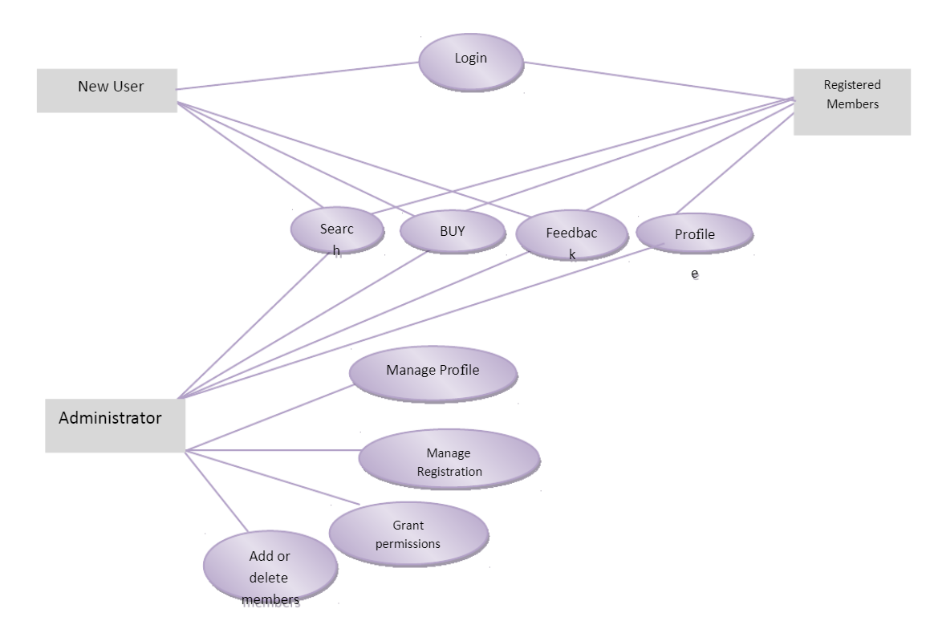

Use case diagrams (UML) are usually referred to as behavior diagrams used to describe a set of actions (use cases) that some system or systems (subject) should or can perform in collaboration with one or more external users of the system (actors).

Here initially you can see the user w

# 

# **CONCLUSION and improvement:**

However, there are cons of MakeMyTrip beside the pros. The over usage of the application can become addictive to user. People became more engaged to their mobile application and became leak confident to communicate normal in real situation. It is a kind of communication barrier to the user. The Bookings became much slower when there is problem occur such low storage space. Databases get reloaded on a fairly regular basis due to upgrades. The problem with so much data it takes a long time to load and that the loads fail for various reasons at larger scales. The multimedia features in the application are heavy and its own size of storage. Not only that, but this application also only works if there is online connection. Using data plan maybe a bit secure and Wi-Fi connection because there are many chances the connection might be disconnected.

Some improvement that MakeMyTrip should make according to collected reviews of users are:

1. MakeMyTrip Should works on app upgrades, wider positioning in all types of travel
2. Customer Support should need to provide properly.
3. Refund Amount Should need to deposit on small time to respective bank accounts.
4. Ticket cancellation charges should be minimum so, that it could attract maximum number of customers towards it.